**LAB # 8**

**Deadlock in concurrency:**

**OBJECTIVE:**

Implementing multiple thread blocked resources with help of lock and deadlock conditions.

**Lab Task:**

Create three threads by implementing thread synchronization block through 3 locks. (Hint: Apply un-sequenced lock to analyze deadlock and solve it through provided solution).

**SOL:**

* **DeadLock Class:**

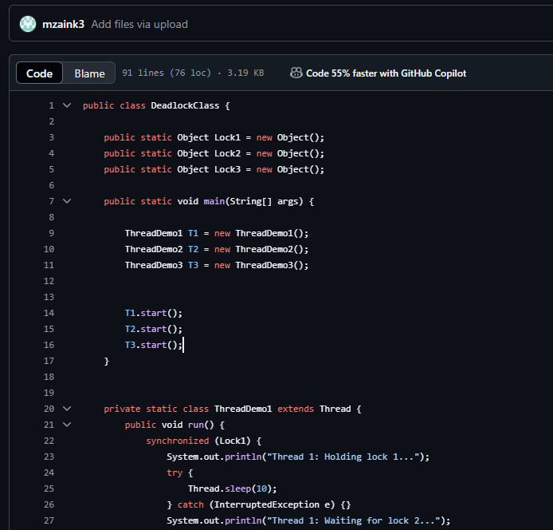 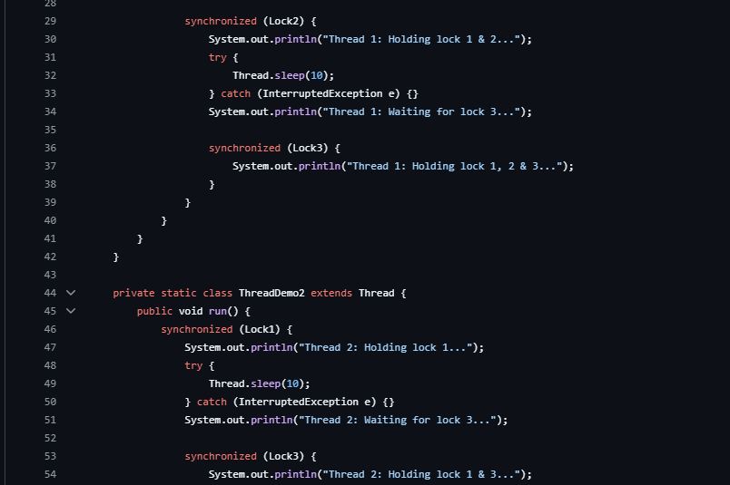

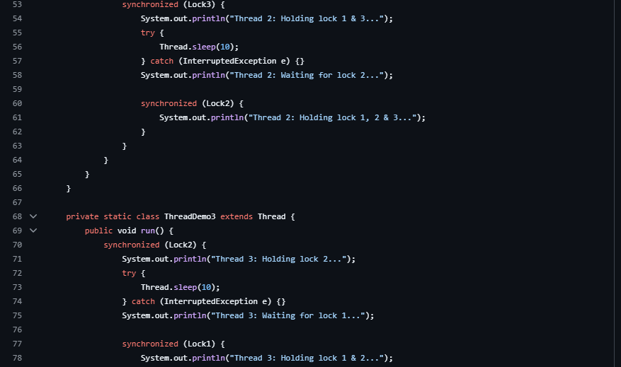

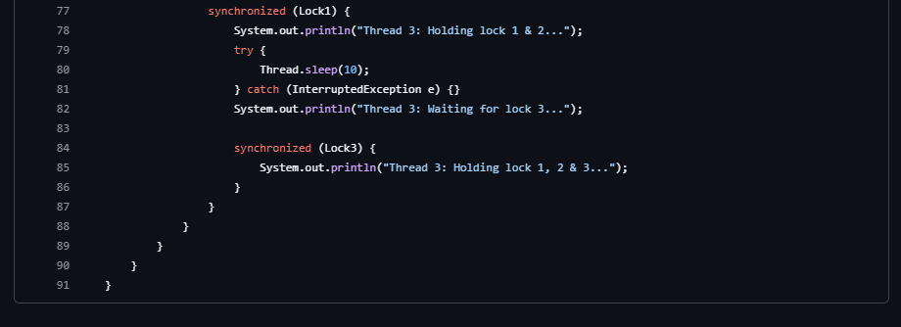

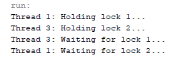

* **Solved Class:**

